To prospective parents,

***Our mission*** is to foster a fun nurturing Christian educational environment for children to experience learning about themselves, their community, their culture, and the environment.

***Our vision*** is to develop happy and healthy critical thinkers through providing learning experiences that cultivates the natural love of inquiry based learning through a morally and culturally relevant curriculum.

Chosen Freedom Academy, CFA, is founded by Aina Johnson M.Ed., Ed.S. She is an educator of 19 years and has acquired several awards for her excellence in teaching including being the “Teacher of the Year” in DeKalb County Schools. CFA is an early childhood learning center located South West Atlanta, Georgia. The program will provide structured educational learning experiences that are grounded in Montessori and culturally relevant instruction through experiential learning for children 2-3 years of age (exceptions can be made for the child’s age)

The following is the list of dates for learning experiences:

|  |  |  |
| --- | --- | --- |
| **Dates** | **Topic** | **Learning Aspects** |
| February 26th, 2022 | Planting- Egg Shell Planters | Discussions and analyzing how plants grow |
| March 12th, 2022 | Paint Fizz | Creating paint and creative images and shapes |
| March 26th, 2022 | Gelatin Dig | Creating a simulation of the sea while exploring the creatures of the Sea |
| April 9th, 2022 | Lava Lamp | Creating and analyzing chemical reactions |
| April 23rd, 2022 | Rainbow Necklace | Creating, counting, and evaluating the colors of the rainbow |
| May 7th, 2022 | Jumping Raisins | Floating vs. Sinking |
| May 21st, 2022 | Celebration in a Jar | Sensory Play- Meaningful Play |
| June 4th, 2022 | Mess Free Painting | Analyzing Primary and Secondary Colors |
| June 18th, 2022 | Number, Colors, and Letters Field Day | Measuring the growth and having fun doing it |

**Directions to Sign-Up/Pay/Prepare**

**Step 1:** Text- I want my child to attend to 404-971-3132 (This will allow me to assure you there is availability)

**Step 2:** Pay Drop in with Kid fee- $30.00 **OR** Dropping child off fee- $40.00 (Cash App $AinaCJohnson or Apple Pay) Upon receipt of payment your child will be added to the roster to ensure their space. This will be the only manner to RSVP.

**Step 3:** Sign-Up using the QR Code **OR** the link

**SIGN-UP FORM (Needs to be completed for each experience)**

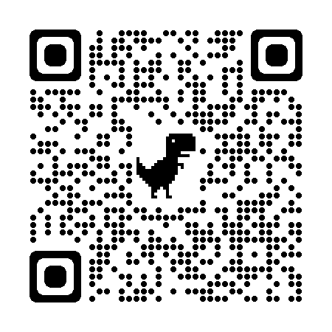

**OR**

<https://forms.gle/wSsVtCmyA9qh2j4G8>

**Step 4:** Complete the following forms on the QR Code or Link (This will only need to be completed the first time you attend)

**Form 1 PARENT/CHILD’S INFORMATION**

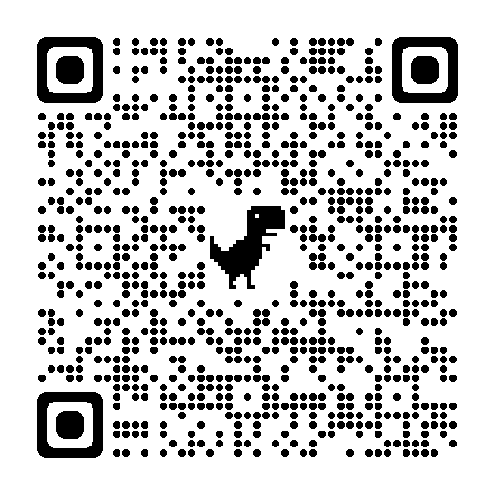

**OR**

<https://forms.gle/SmDXUJ8R5TsgyE5q6>

**Form 2 MEDIA RELEASE FORM**

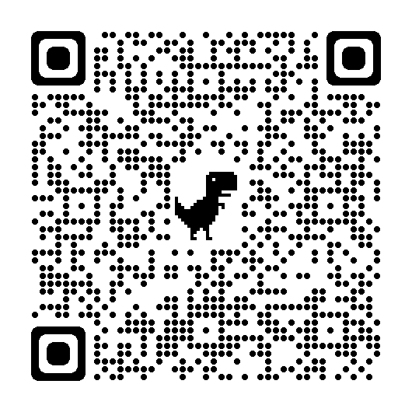

**OR**

<https://forms.gle/Pz6dMUZihjGarGrV8>

**How to Prepare for the Experience**

* Children should come in comfortable clothing that is ready to explore and experience their learning.
* Snacks will be provided (Please bring cup with beverage for your child. It will be kept in the refrigerator until snack time).
* Please do not allow children to bring their personal toys to ensure they are not broken or distractors for the kids.
* Please leave changing materials (Diaper/wipes/pull-ups/extra clothing) for your child.
* The experience starts at 9:00 a.m. if you are late please come in quietly and join the experience.
* The experience ends at 12:00 p.m. please come at 11:50 a.m. to pick your child up.
* We are excited if you want to participate as a parent. To ensure we provide a safe and clean community we ask that you wear a mask at all times. In addition, if you are sick or have any cold symptoms please do not attend the experience.
* A survey will be provided after each experience to ensure we are providing the best educational experience possible for your child.

We look forward to learning with your child and you,

Aina Johnson M.Ed, Ed.S

Director of Chosen Freedom Academy

[ChosenFreedomAcademy@gmail.com](mailto:ChosenFreedomAcademy@gmail.com)

404-971-3132